The McDavid Paradox: How the World's Best Player Can Unlock Another Level
Connor McDavid is the best hockey player on the planet. That’s not a take. That’s a fact supported by every meaningful metric the sport produces.
So what I’m about to show you isn’t a criticism. It’s something more interesting — a specific, coachable, data-confirmed gap between where McDavid already is and where he could be. A gap worth multiple goals in a playoff series. A gap that could be the difference between another first-round exit and a deep Cup run.
The data found something the eye test misses entirely.
As a side note this is builds on the HockeyROI net-front series. You don’t need to read the foundation post — The Geometry of Winning — but it would give you context.

He’s Already Doing Everything Right
Start with what the data confirms McDavid does well, because this matters for understanding the finding.
His net-front positioning is elite. Across six seasons his average shot position from net-front attempts sits at x=80.6, y=0.8 in normalized coordinates. That’s essentially the crease dot, dead centre, right where the data says dangerous rebounds land.
His timing is elite. His average gap between the original shot and his rebound attempt is 1.48 seconds career average, faster than most forwards in the league. In 2025-26 that dropped to 1.25 seconds, a career best. He’s arriving at the doorstep before the goalie fully resets.
His volume is elite. 204 net-front attempts over six seasons, 90 rebound sequences. He’s going to the net. Consistently. On purpose.
Every input the model measures for net-front positioning, where he goes, when he gets there, how often, says McDavid is doing it right.
The output tells a different story.

The Conversion Gap
McDavid’s overall net-front goal rate across six seasons: 9.2%.
The league average on net-front attempts: 13.57%.
He’s converting at 68% of the league average rate. From the same spot. Getting there faster than almost anyone.
Compare that to the league’s best net-front finishers and the gap widens further. Elite net-front forwards convert at 22-27% from the doorstep zone. McDavid is converting at less than half that rate despite elite positioning and timing.
Something specific is going wrong between arrival and conversion. The data identifies exactly what.

The Wrist Shot Problem
Break McDavid’s net-front attempts down by shot type and the finding is stark.

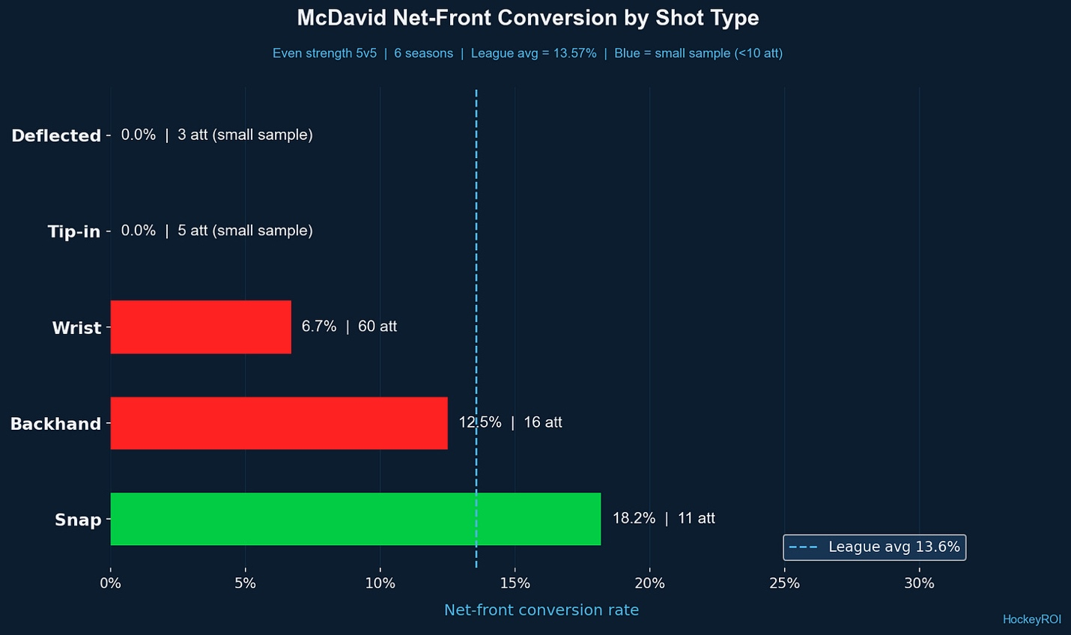

Wrist shots on rebounds: 60 attempts over six seasons. 4 goals. 6.7% conversion rate.
The league average on wrist shot rebounds: 13.5%.
McDavid converts wrist shot rebounds at exactly half the league average rate. And wrist shots make up 55% of his net-front attempts — the majority of what he’s trying when he gets to the right spot.
The last three seasons specifically: 0 goals on 27 wrist shot rebound attempts. Zero. In three years. From the doorstep zone. The best player in the world.

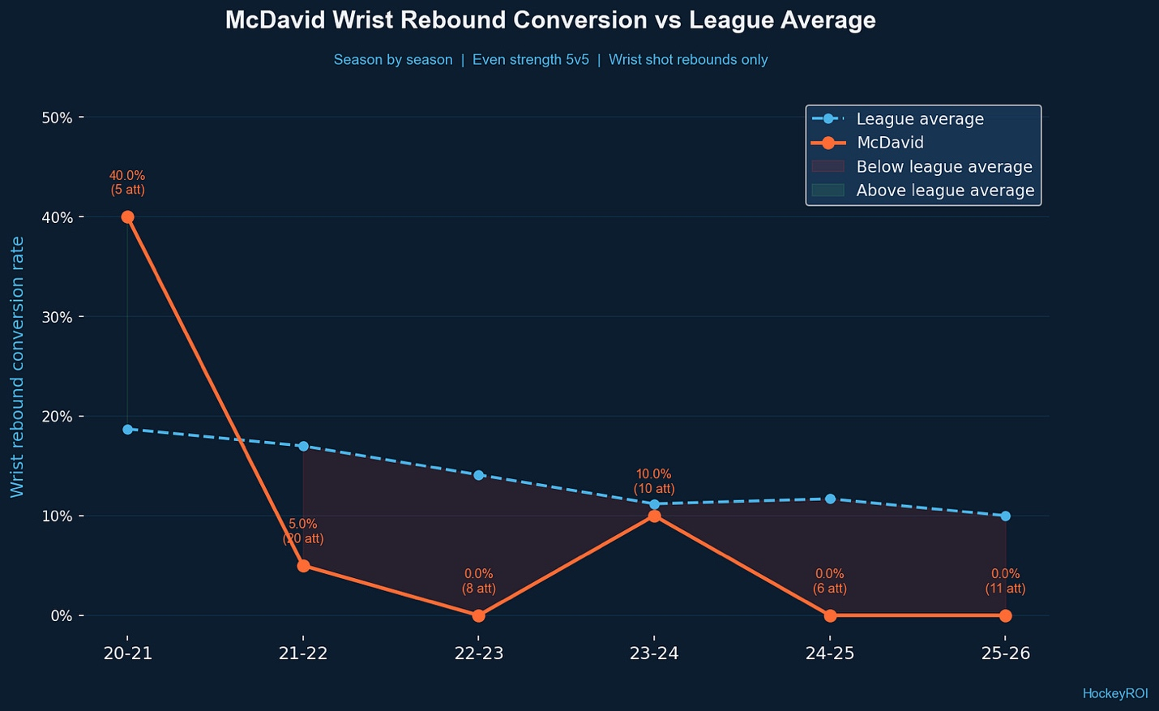

This isn’t variance. At 27 attempts over three seasons, the probability of this being random noise is extremely low. This is a pattern. A specific, consistent, identifiable pattern.

Why It’s Happening
The data can’t film McDavid’s stick blade angle. But it tells us enough to form a clear hypothesis.
In open ice McDavid’s wrist shot is one of the most dangerous in the league — quick release, deceptive, accurate. Those mechanics work from 20-40 feet with time and space.
At the crease in a rebound situation you have none of those things. The puck is moving unpredictably. A defender is on your back. The goalie is scrambling. You have less than two seconds. The mechanics that make a wrist shot elite in open ice, the backswing, the weight transfer, the follow-through, these become liabilities in a 2-foot space under pressure.
The best net-front finishers in the league don’t shoot wrist shots in tight. They redirect. They one-touch. They tip. They use the puck’s momentum rather than generating their own.
McDavid is arriving at the right spot and reverting to his open-ice mechanics. The shot that wins in space fails at the crease.

What Works
Here’s the important part. When McDavid uses different shot mechanics at the net the data changes completely.
Snap shots on net-front attempts: 11 attempts, 2 goals, 18.2% conversion. Above league average.
Backhand attempts: 16 attempts, 2 goals, 12.5%. Near league average.
The shots with a shorter, quicker release (less backswing, more redirect) work at league average rates or better. The full wrist shot mechanics fail.
This is coachable. This is specific. This is not about effort, willingness, or hockey sense. McDavid already goes to the right spot at the right time. The only thing that needs to change is what he does with the puck when he gets there.

2025-26: Something Is Changing
There’s an encouraging signal in this season’s data.
McDavid’s timing gap dropped to 1.25 seconds this season, the fastest of his career. He’s arriving at rebounds earlier than ever. That suggests awareness of the problem and a deliberate adjustment in how he reads the play.
The conversion rate hasn’t caught up yet, 5.0% on 20 attempts this season. But the sample is small and timing improvement typically precedes conversion improvement. You fix the arrival first, then you fix what you do when you get there.
The fact that his timing is improving in the same season the Oilers need him most is the most encouraging data point in this entire analysis.

What It’s Worth
McDavid averages roughly 35 net-front attempts per season at even strength. If he converts at the league average rate instead of his current rate, going from 9.2% to 13.57%, that’s approximately 1.5 additional even strength goals per season from the net-front alone.
In a seven-game playoff series where McDavid might generate 8-10 net-front opportunities, the difference between his current conversion rate and league average is roughly one goal. One goal in a playoff series is everything.
If he can convert at the rate elite net-front finishers manage, 22-27%, the number becomes 2-3 additional goals in a series.
That’s not a marginal improvement. That’s a potential series-changing edge hiding in plain sight.

The Playoff Implication
Game 1 against Anaheim is tonight.
Watch for McDavid at the net. He’ll get there — the data guarantees that. He gets there faster than almost anyone. He gets to the right spot every time.
Watch what he does when he gets there. If he’s shooting redirects and one-touch attempts rather than full wrist shots, the adjustment is happening in real time. If the puck is going in more than usual from the doorstep zone, this analysis aged well before the ink dried.
The Oilers don’t need McDavid to become a different player. They need him to do one specific thing differently in one specific situation. The data says that thing is worth multiple goals if he cracks it.
The best player in the world getting 5% better at one coachable skill. That’s not a weakness story. That’s an upside story.

Model note: Six seasons of NHL API shot data. Net-front attempts defined as tip-ins, deflections, and rebound sequences at even strength. Shot type analysis based on 109 career net-front attempts with recorded shot type. Small sample caveat applies to individual shot type breakdowns, wrist shot finding is the most statistically robust given n=60. Full methodology at github.com/HockeyROI/nhl-analytics.
@HockeyROI on X | hockeyROI.substack.com
Top of Form
Bottom of Form

